**Creating Microservices for Account and Loan**

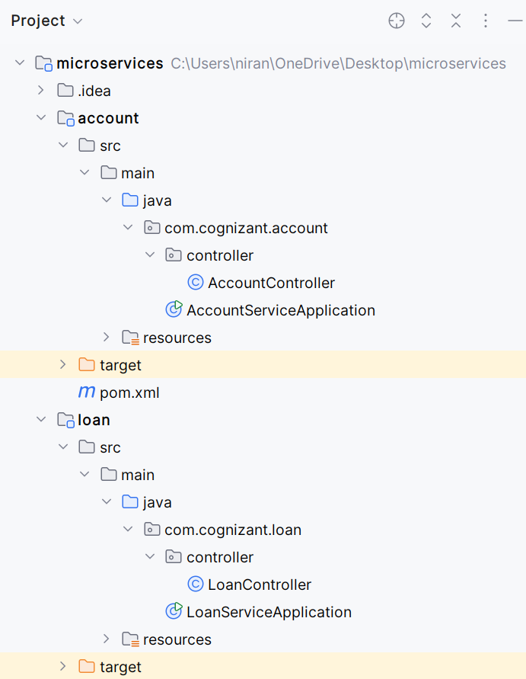

**AccountServiceApplication.java**

package com.cognizant.account;

import org.springframework.boot.SpringApplication;

import org.springframework.boot.autoconfigure.SpringBootApplication;

@SpringBootApplication

public class AccountServiceApplication {

public static void main(String[] args) {

SpringApplication.run(AccountServiceApplication.class, args);

}

}

**AccountController.java**

package com.cognizant.account.controller;

import org.springframework.web.bind.annotation.*;

import java.util.HashMap;

import java.util.Map;

@RestController

@RequestMapping("/accounts")

public class AccountController {

@GetMapping("/{number}")

public Map<String, Object> getAccountDetails(@PathVariable String number) {

Map<String, Object> response = new HashMap<>();

response.put("number", number);

response.put("type", "savings");

response.put("balance", 234343);

return response;

}

}

**Application.properties**

server.port=8080

**pom.xml**

<project xmlns="http://maven.apache.org/POM/4.0.0"

xmlns:xsi="http://www.w3.org/2001/XMLSchema-instance"

xsi:schemaLocation="http://maven.apache.org/POM/4.0.0

http://maven.apache.org/xsd/maven-4.0.0.xsd">

<modelVersion>4.0.0</modelVersion>

<groupId>com.cognizant</groupId>

<artifactId>account</artifactId>

<version>0.0.1-SNAPSHOT</version>

<packaging>jar</packaging>

<name>account</name>

<description>Account Microservice</description>

<parent>

<groupId>org.springframework.boot</groupId>

<artifactId>spring-boot-starter-parent</artifactId>

<version>3.1.2</version> <!-- Use the latest stable version -->

<relativePath/> <!-- lookup parent from repository -->

</parent>

<properties>

<java.version>17</java.version> <!-- Match your local JDK -->

</properties>

<dependencies>

<!-- Spring Web -->

<dependency>

<groupId>org.springframework.boot</groupId>

<artifactId>spring-boot-starter-web</artifactId>

</dependency>

<dependency>

<groupId>org.springframework.boot</groupId>

<artifactId>spring-boot-devtools</artifactId>

<scope>runtime</scope>

<optional>true</optional>

</dependency>

<dependency>

<groupId>org.springframework.boot</groupId>

<artifactId>spring-boot-starter-test</artifactId>

<scope>test</scope>

</dependency>

</dependencies>

<build>

<plugins>

<!-- Spring Boot Maven Plugin -->

<plugin>

<groupId>org.springframework.boot</groupId>

<artifactId>spring-boot-maven-plugin</artifactId>

</plugin>

</plugins>

</build>

</project>

**LoanServiceApplication.java**

package com.cognizant.loan;

import org.springframework.boot.SpringApplication;

import org.springframework.boot.autoconfigure.SpringBootApplication;

@SpringBootApplication

public class LoanServiceApplication {

public static void main(String[] args) {

SpringApplication.run(LoanServiceApplication.class, args);

}

}

**LoanController.java**

package com.cognizant.loan.controller;

import org.springframework.web.bind.annotation.*;

import java.util.HashMap;

import java.util.Map;

@RestController

@RequestMapping("/loans")

public class LoanController {

@GetMapping("/{number}")

public Map<String, Object> getLoanDetails(@PathVariable String number) {

Map<String, Object> response = new HashMap<>();

response.put("number", number);

response.put("type", "home");

response.put("loanAmount", 550000);

return response;

}

}

**application.properties**

server.port = 8081

